**Power BI in one line:**Power BI is Microsoft’s business analytics tool that helps visualize, share, and interact with data through dashboards and reports.

**Features of Power BI (3 lines with examples):**

1. Data Connectivity & Integration – Connects to 100+ data sources (e.g., Excel, SQL Server, Azure, Salesforce).
2. Interactive Visualizations & Dashboards – Drag-and-drop charts, maps, KPIs (e.g., sales dashboard showing revenue by region).
3. AI & Natural Language Queries – Users can type questions like *“Show sales growth by month”* and get instant visuals.

**Feature Tableau has that Power BI doesn’t:**👉 Tableau has better advanced data visualization customization (e.g., more granular control over design, formatting, and storytelling dashboards).

**Feature Power BI has that Tableau doesn’t:  
👉** Power BI offers seamless integration with Microsoft ecosystem (Excel, Teams, Azure, Power Apps) and AI-powered insights directly inside the tool.

**WAYS TO IMPORT DATA IN POWER BI**

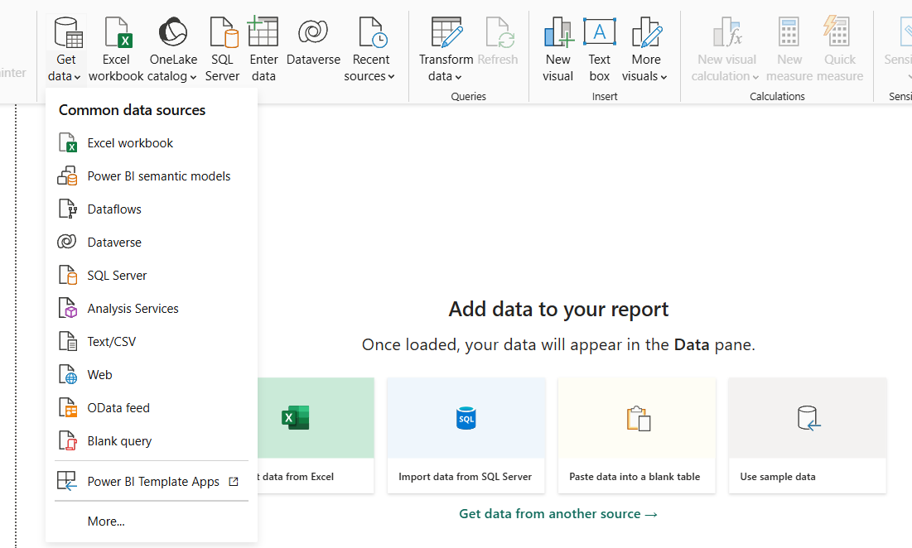

**IMPORTING EXCEL SHEET**

When we import the excel sheet data it will shows the list of sheets available in that file like below.

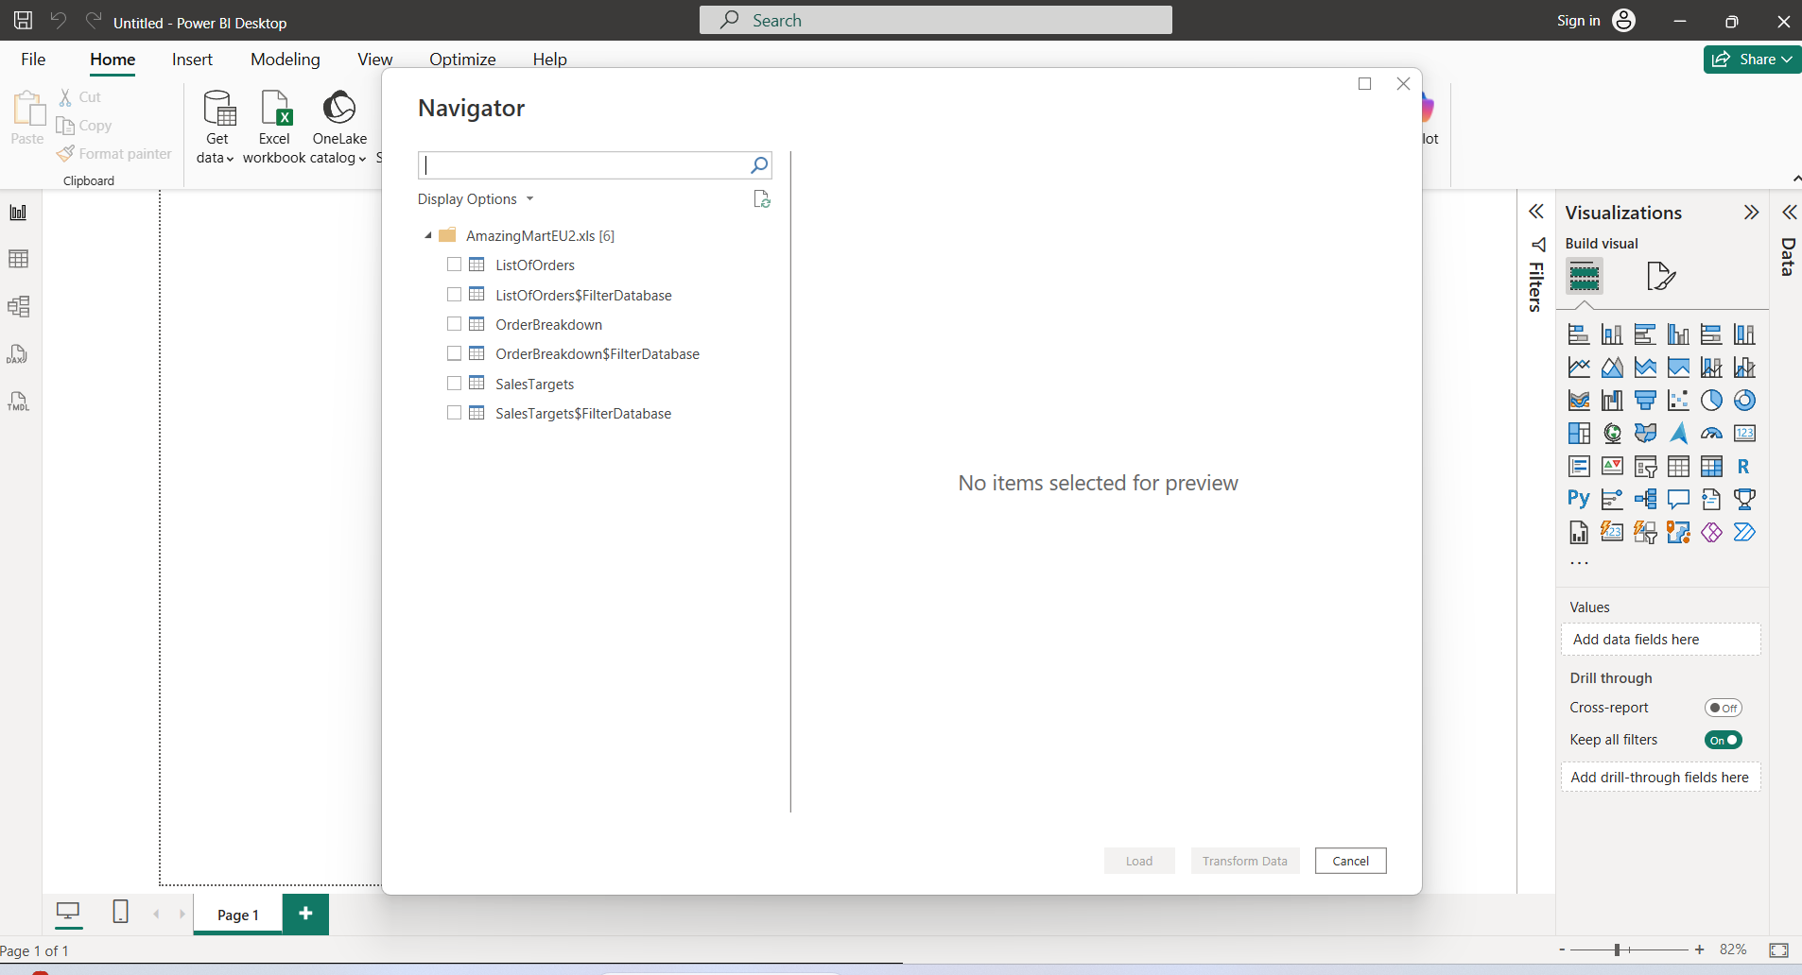

Below is the way we can select the needed sheet to work with power bi,

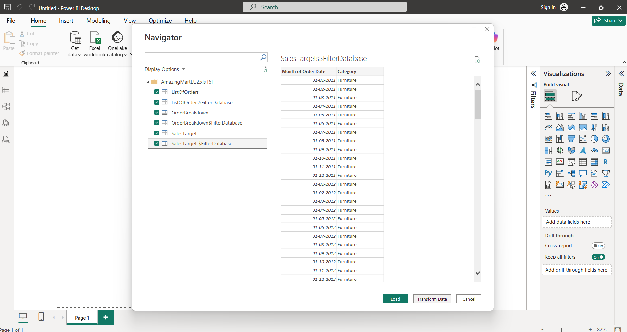

Transform Data = clean/shape data before use, Load Data = bring prepared data into Power BI for reporting. ✅

Below is the initial page when data gets load into the power BI, in left corner it has list of view the highlighted view is table, first view is visualization, third view are helps to see the relationship among different sheet.

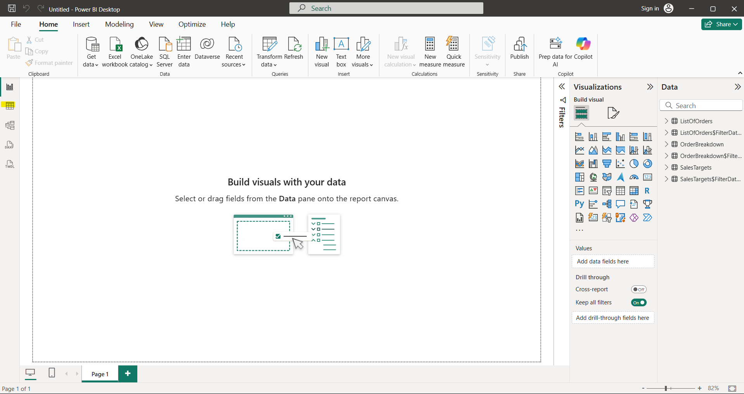

**TRANSFORM DATA IN POWER BI**

With this we an remove add columns

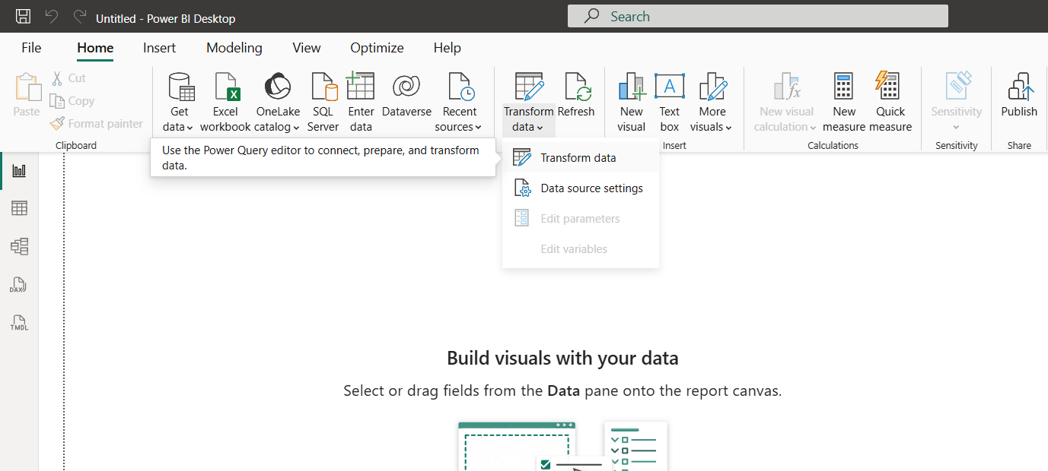

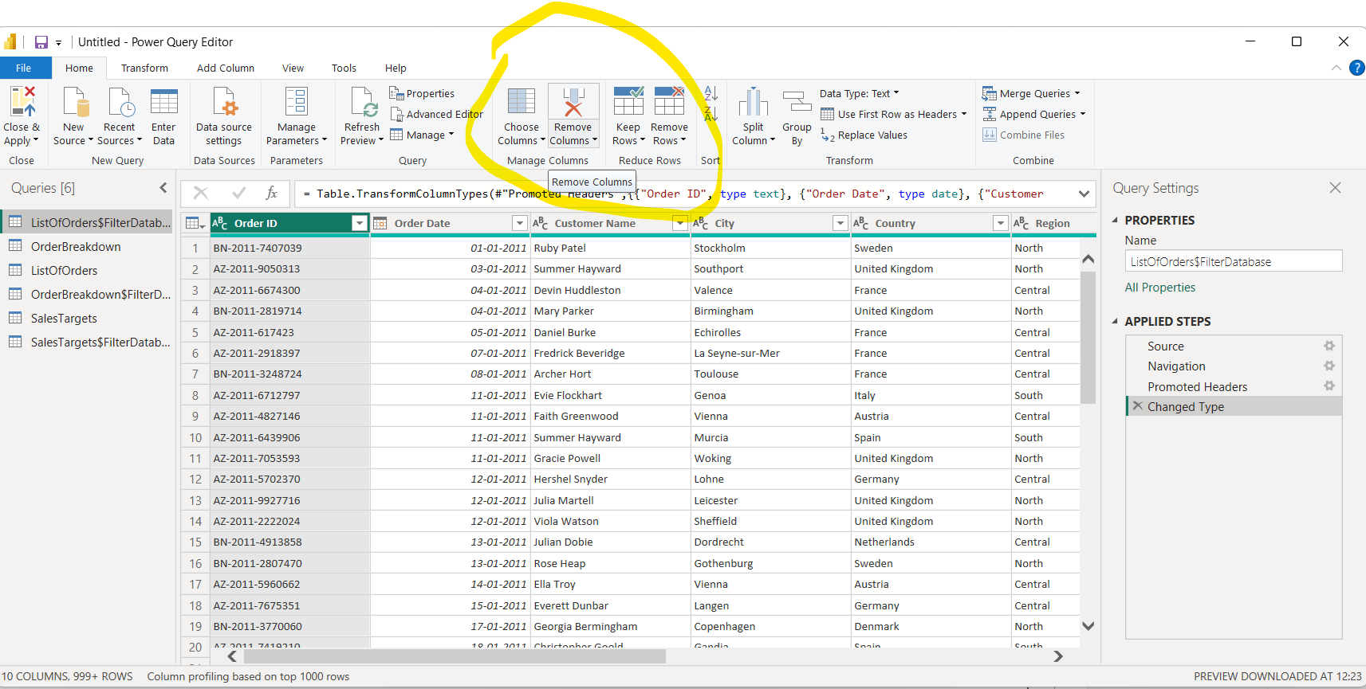

**FILTERING DATA**

All the values will be shown on filter type drop down when we drag and drop the fields into the filter on this page container, by clicking those values we can filter out the data.

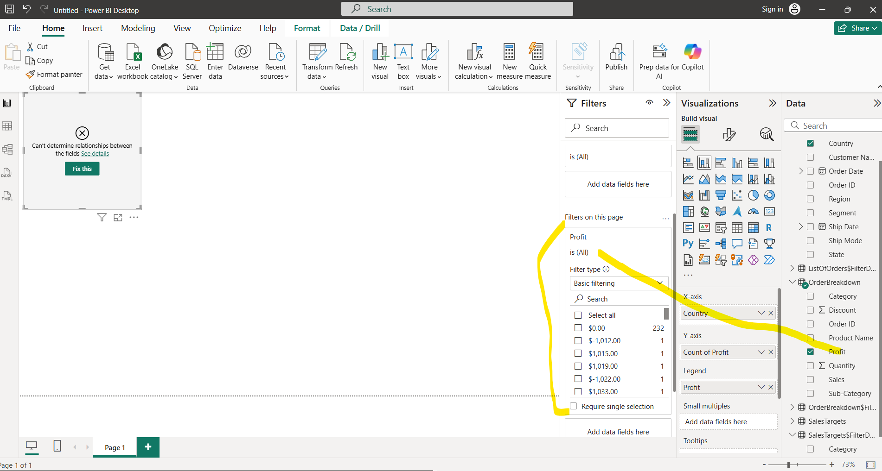

**FOCUS MODE**

Helps to see the full chart in the current page.

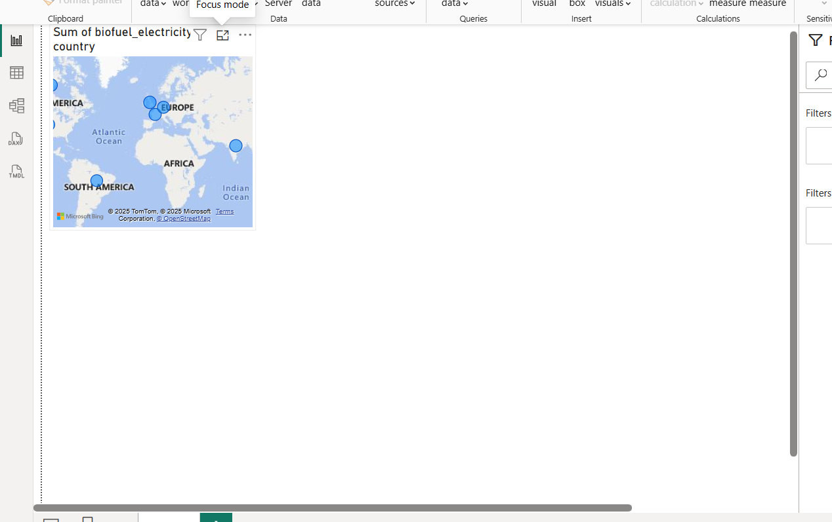

After clicking the focus mode

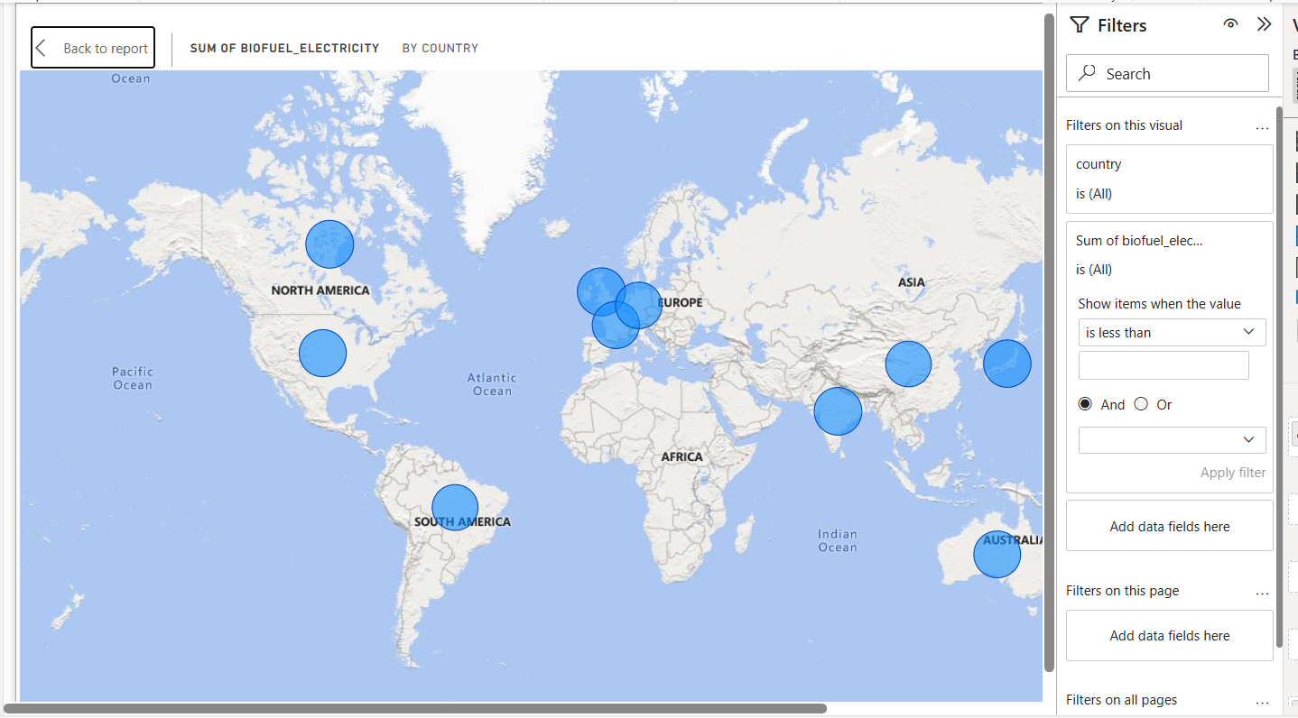

**Note:**

In Power BI, the **Map visual** (or Filled Map) requires some kind of **geographic data** such as:

* Country / State / City
* Latitude & Longitude
* Postal Code / Region

If your dataset (like the one we generated) has **no location-type columns**, then:

* When you try to drag a field into the **Location** well of a Map visual, Power BI won’t know how to plot it.
* It may show an empty map or an error message like *“More location data is needed to create a map.”*
* Power BI might try to guess (for example, treat a column like “token” or “obyte” as location text), but it won’t map correctly unless those values match real geographic names.

✅ To make it work, you’d need to add a **location field** (like "Country" or "City") to the dataset.

**FORMAT CHART LABELS, LEGENDS**

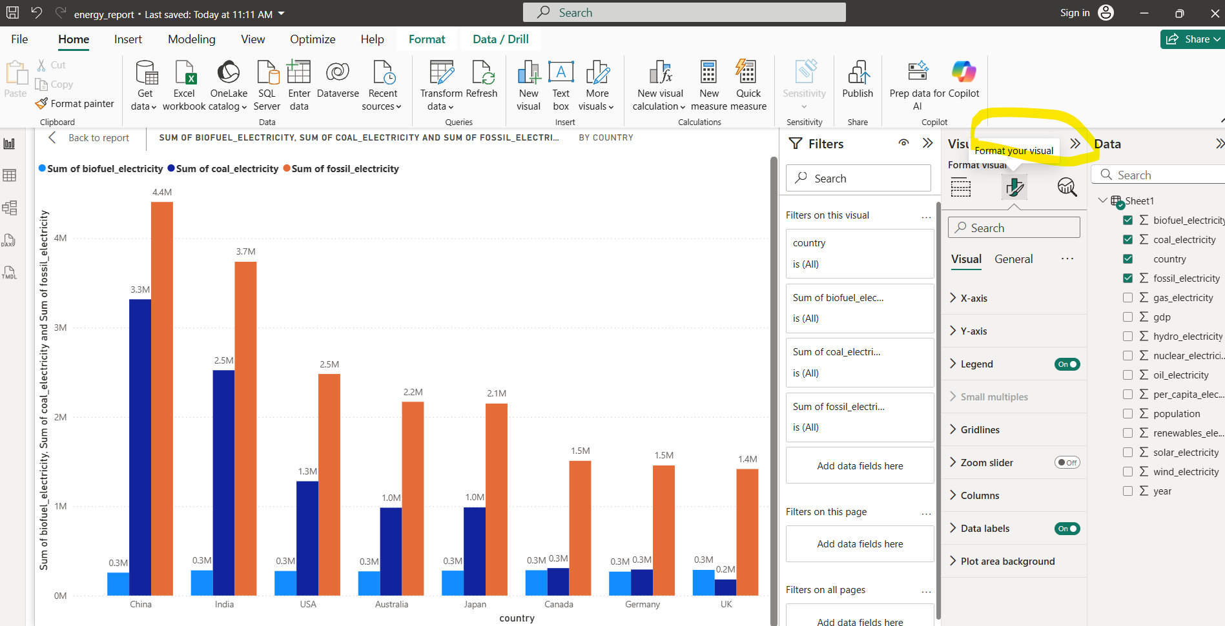

**FILE EXTENSIONS IN POWER BI**

**PBIX** stands for **Power BI eXecutable** (commonly interpreted this way by the community, though Microsoft doesn’t officially expand it).

Other related Power BI file extensions are:

* **.pbit** → **Power BI Template**
* **.pbix** → **Power BI report file (main working file)**

**TOP N FOR BAR CHART**

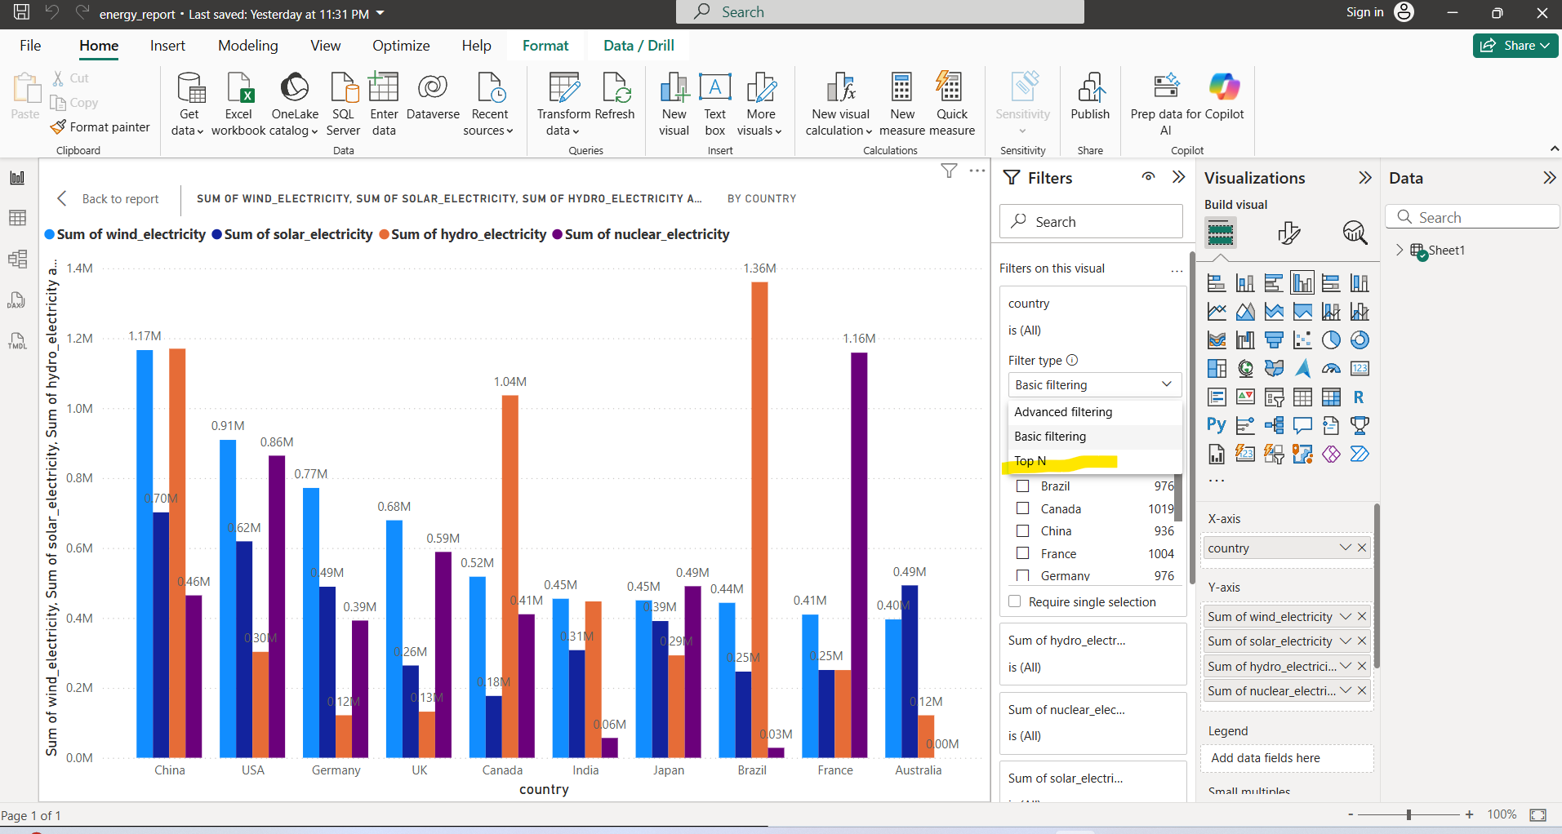

The below chart will displays the Top 5 records which as high hydro energy

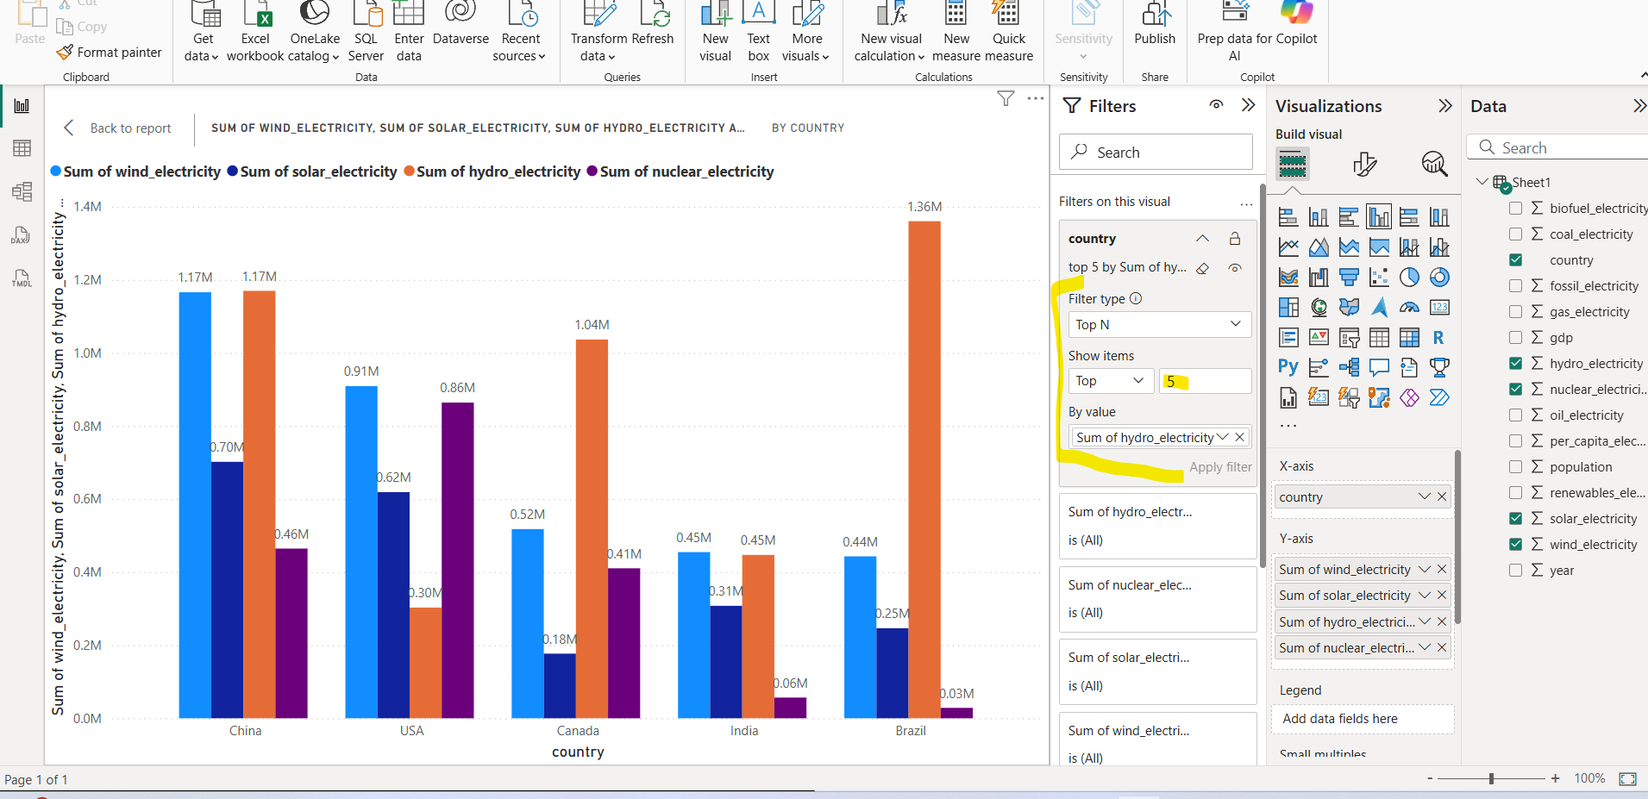

**EXPORTING DATA FROM CHART**

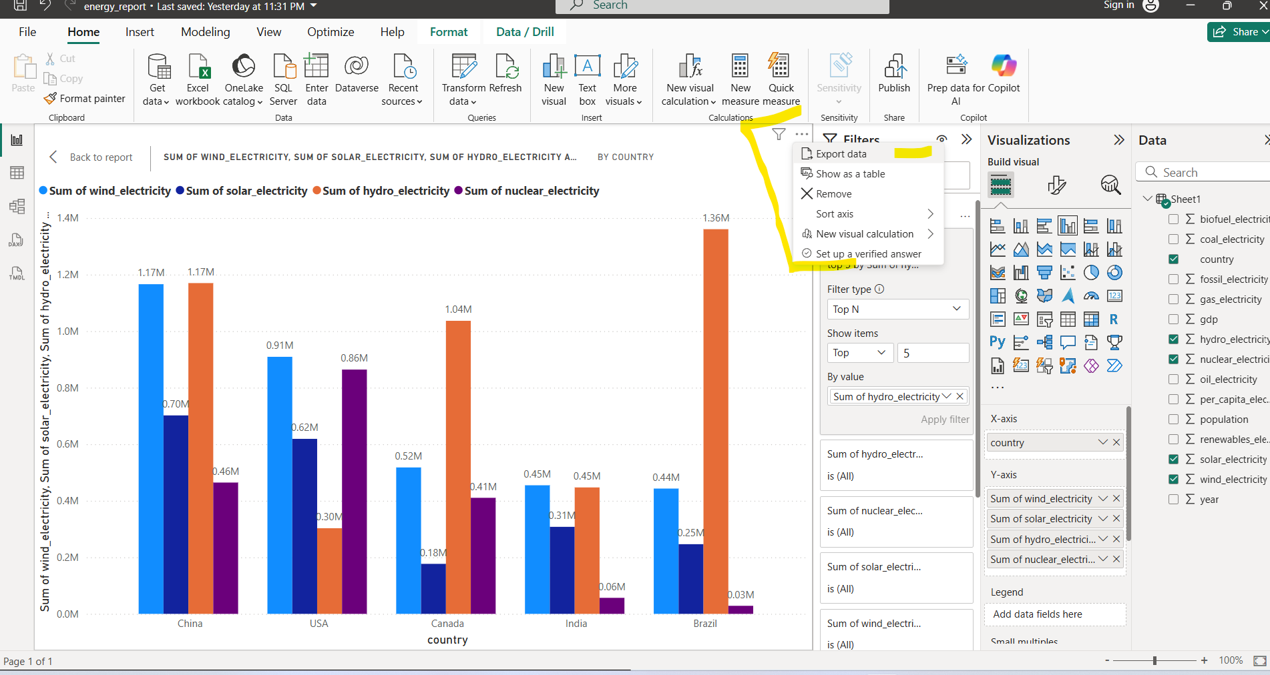

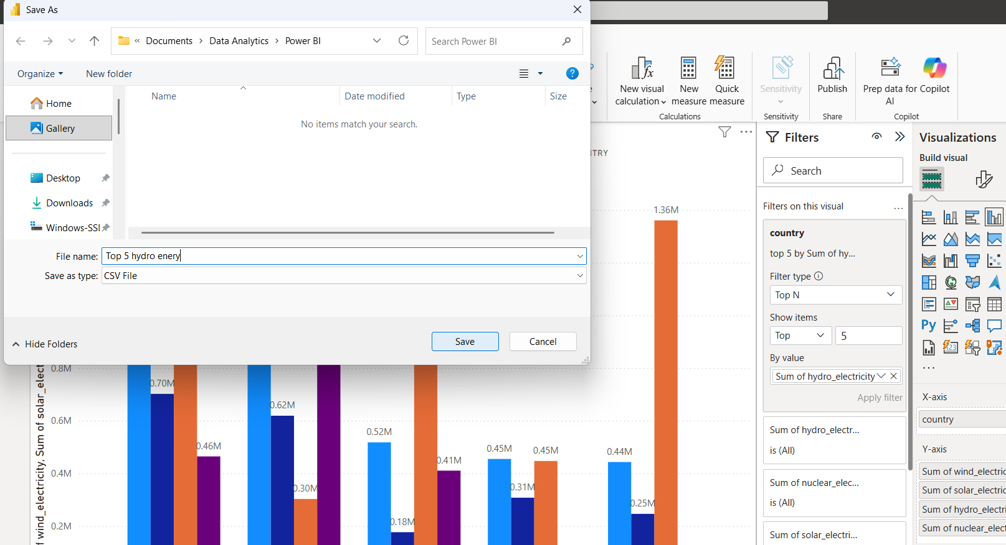

**CHANGING DATA TYPE OF THE COLUMN**

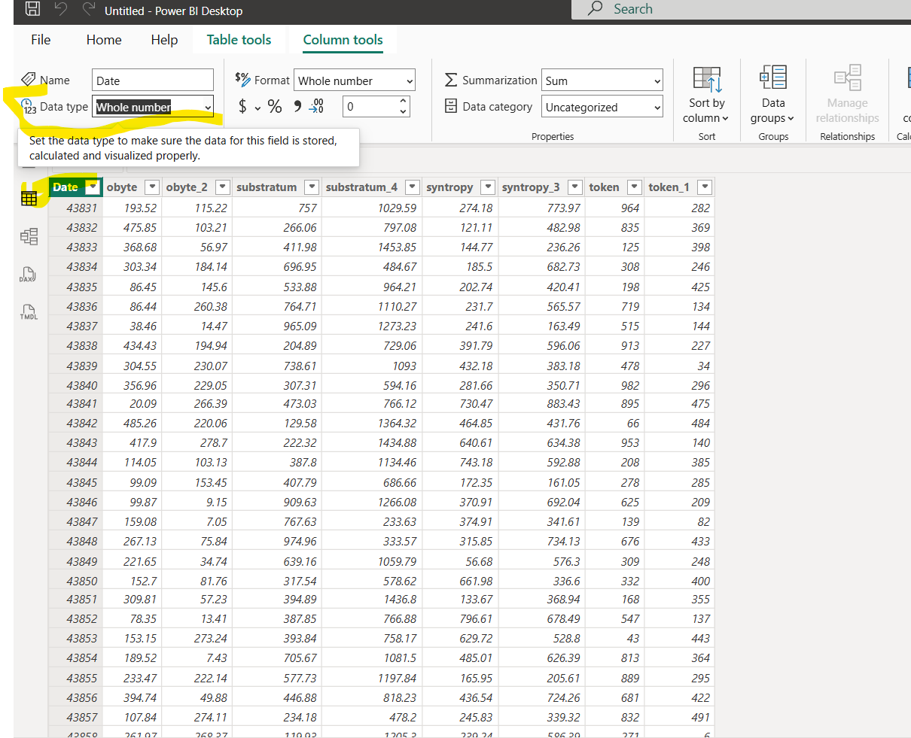

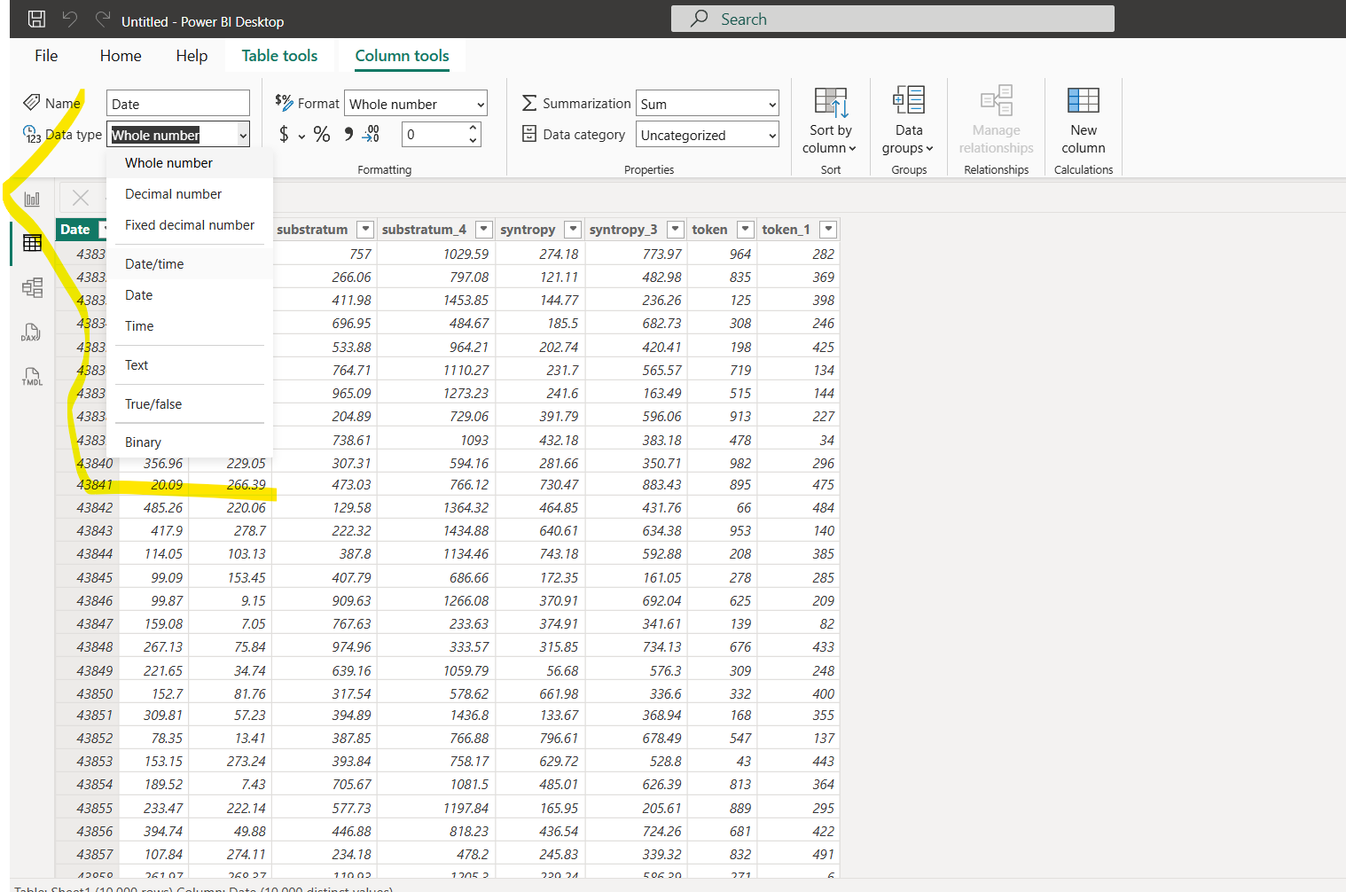

After changing the column to Date/Time the column will look like below

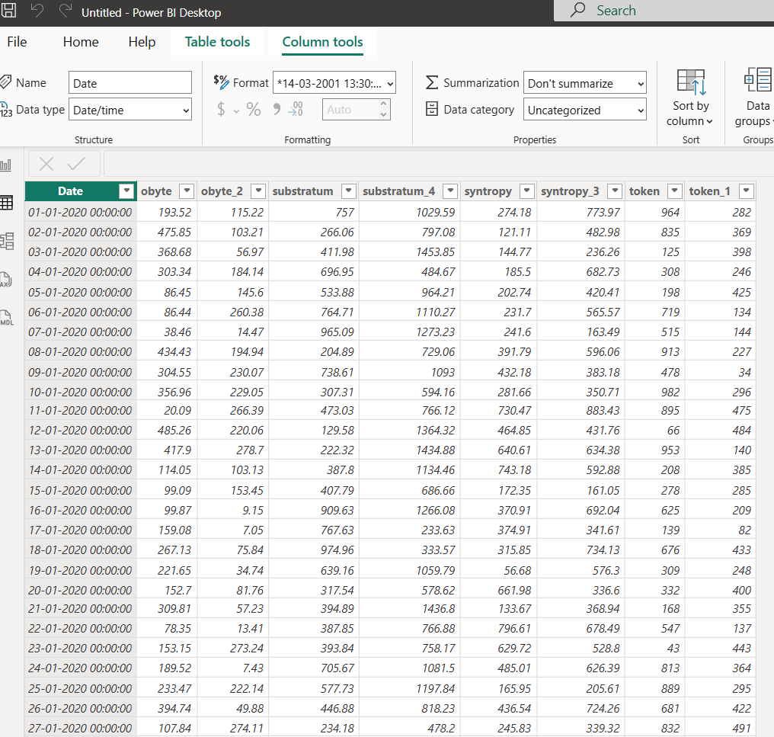

**DECOMPOSITION TREE**

Used to create a decomposed visualization from a range of data like below. Decomposition needs decompose value, in below we selected date as the decomposition value, which has hierarchy data like year, month, quatre, day

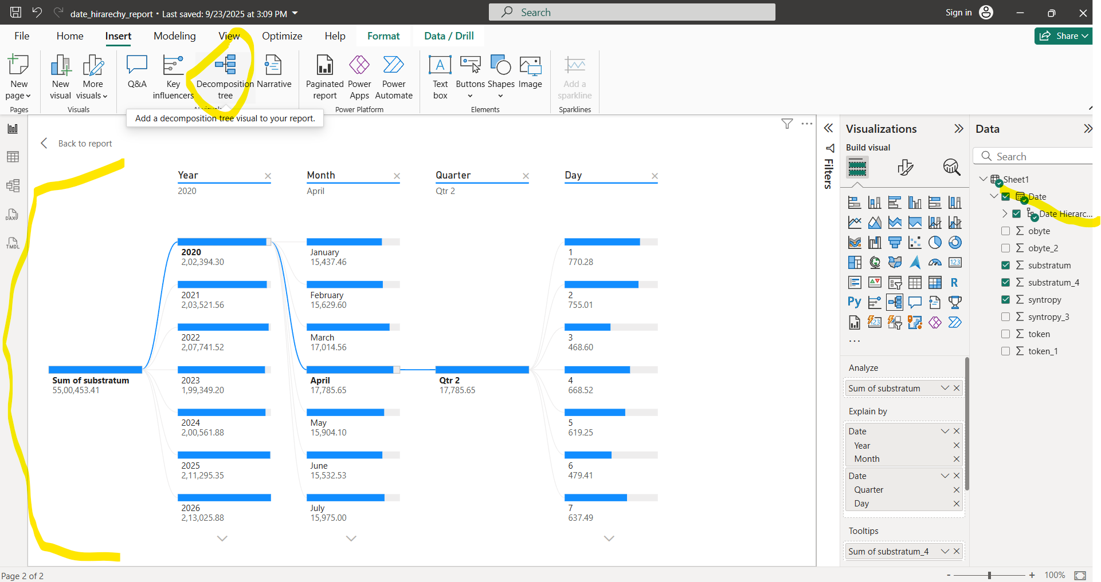

**ADDING Q&A**

When we click QA list of suggested insights which can be created from the dataset we load will be given on to the centre screen like the below one

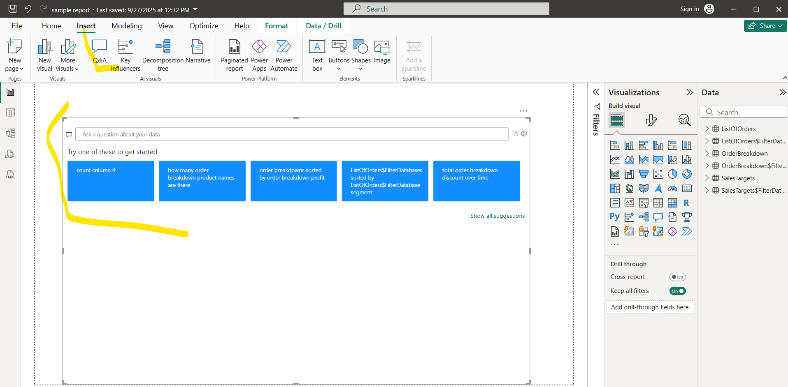

And also we can ask new insight to the AI that can be generated by below way.

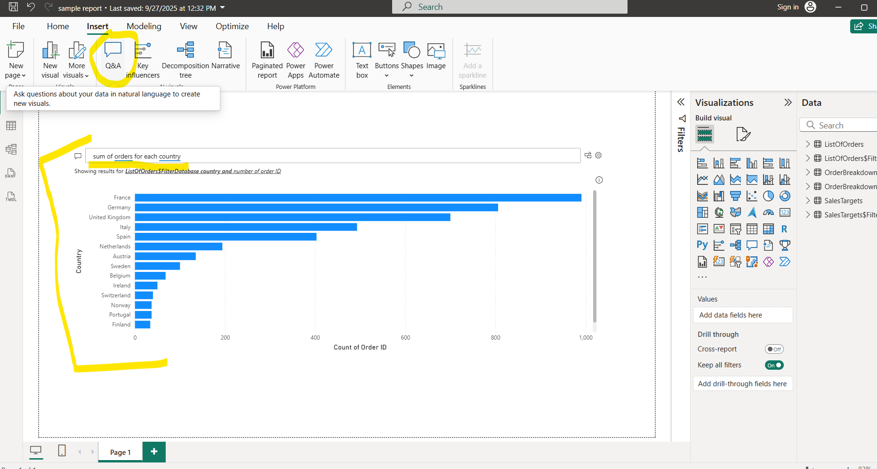

**KEY INFLUENCER**

It takes categorial values and numerical values from the it will make the key influence for that question called why this column having this value now like below

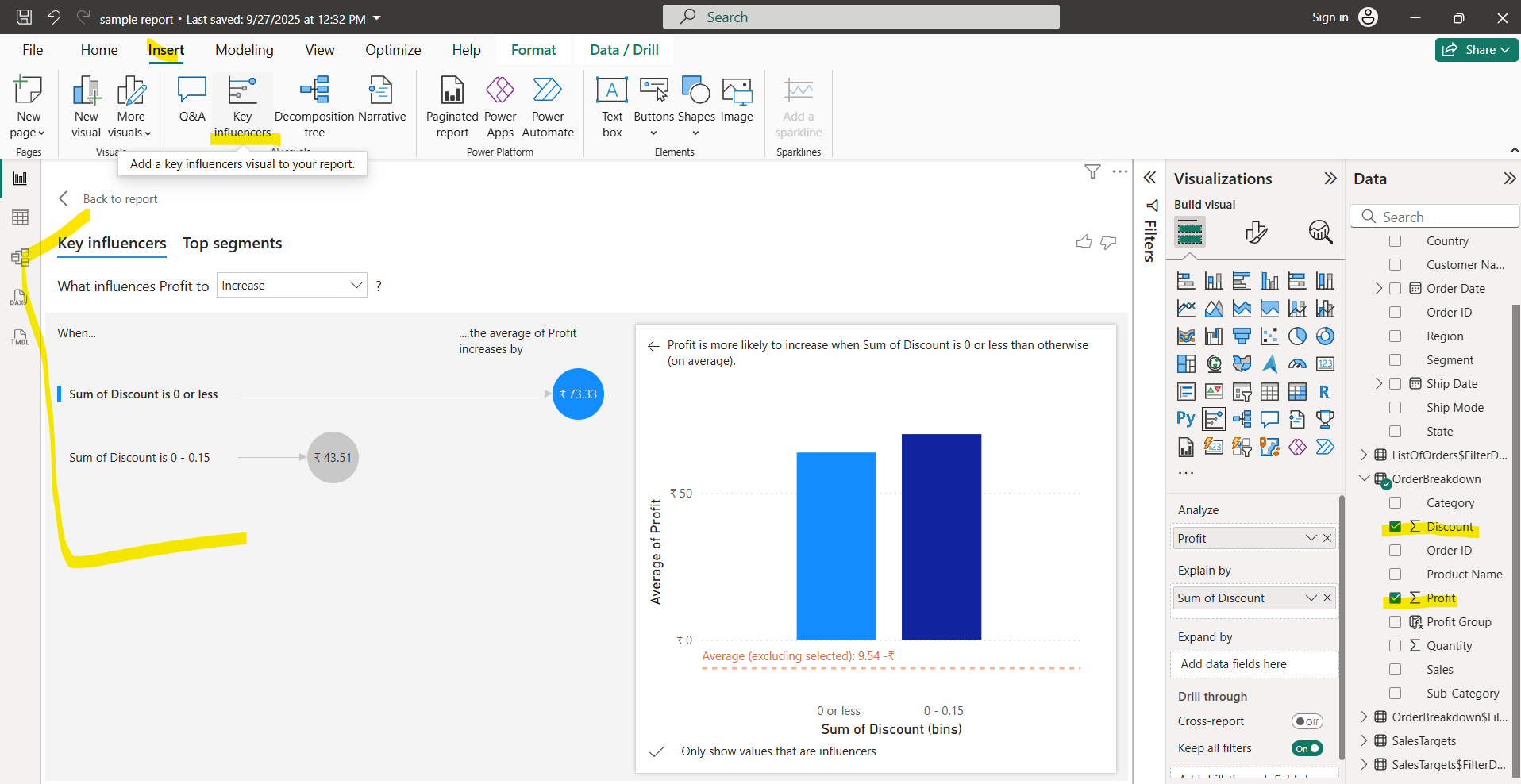

In above we have selected profit(numeric), discount(numeric) fields that tells **“what influences profit to increase”**

Answer give by the AI is **“When sum of the discount is 0 or less the average of profit is increases by 73.33 and When sum of the discount is 0-0.15 or less the average of profit is increases by 43.51”**

**NOTE:** check the data type of the numeric field before going to select it for key influencer, if the numeric data are in text data type then the AI will not try to understand the influencer.

**TOP SEGMENT**

We have another option called top segment in key influence that take whole data and breaks it into segment according to the key influence

In below segment 1 has 1602 data that is the highest average profit, segment 2 has 4909 data that has low average profit

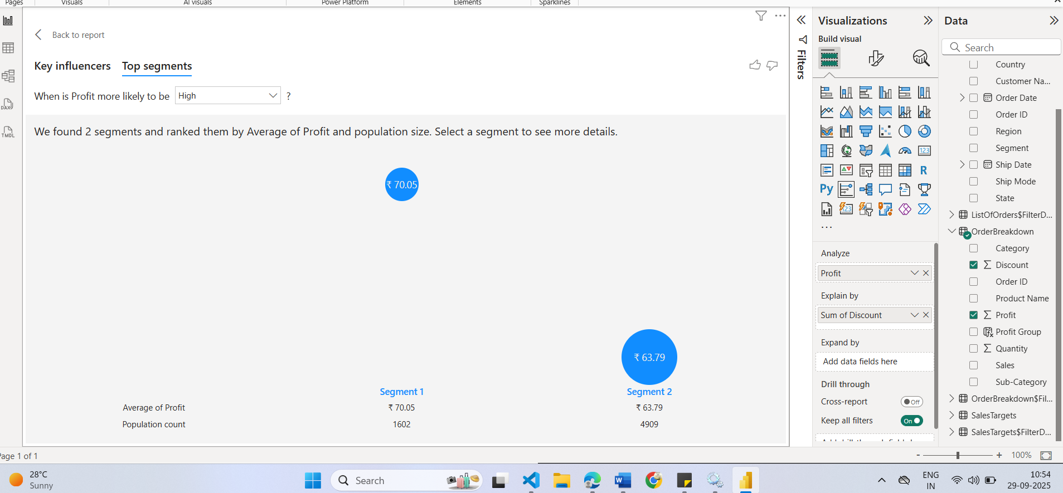

When we double click any of the segment it will show the below details why this segment has high average profit, we got the answer as “**When sum of discount is greater than 0 and is less then or equal to 0.15 segment 1 has 70.05 profit”**

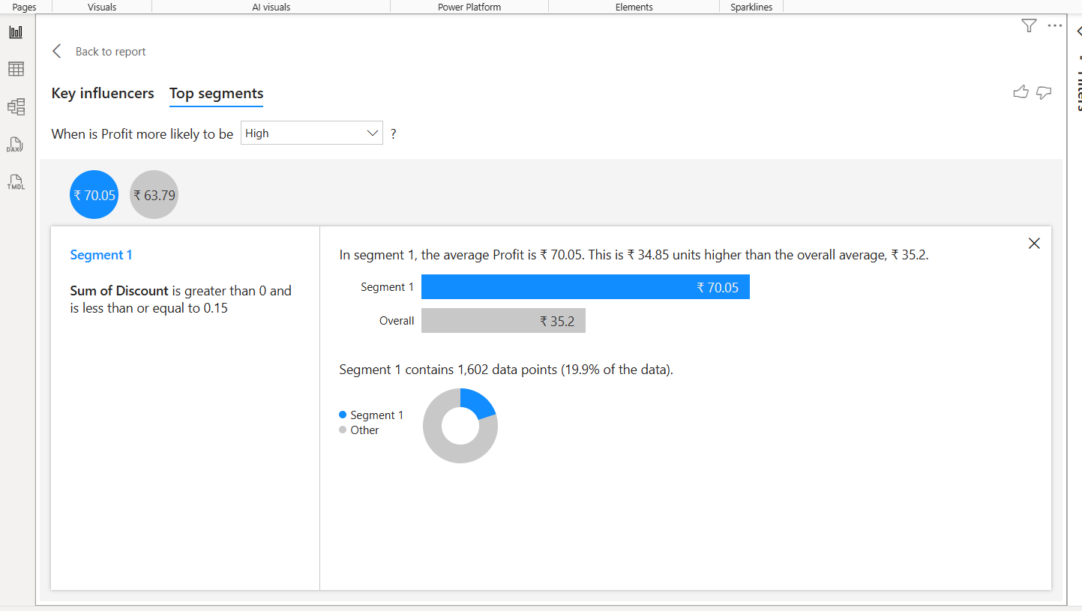

**NARRATIVE**

AI will give you narration of the selected chart as text when you select and click narrative tab, before that we need to login to out copilot account.

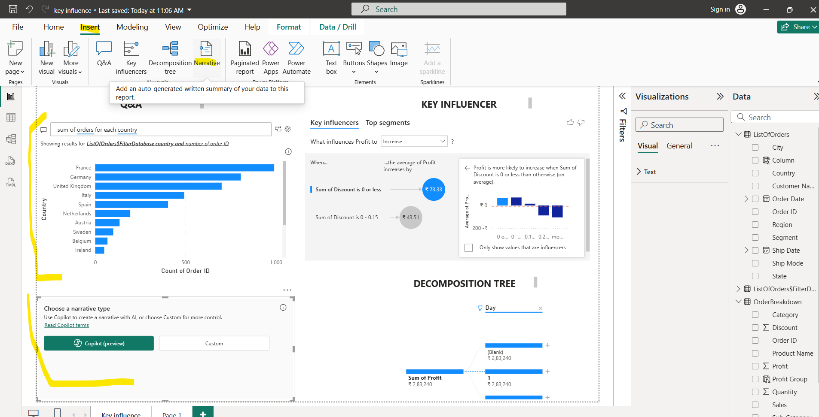

**CREATING RELATION WITH DATA MODELING**

To create new relationship we need common values in both table that identifies each record in unique way. When we load the excel sheet power bi will automatically identify and related those common fields, but if we wan to create new relationship that can be done like below manner

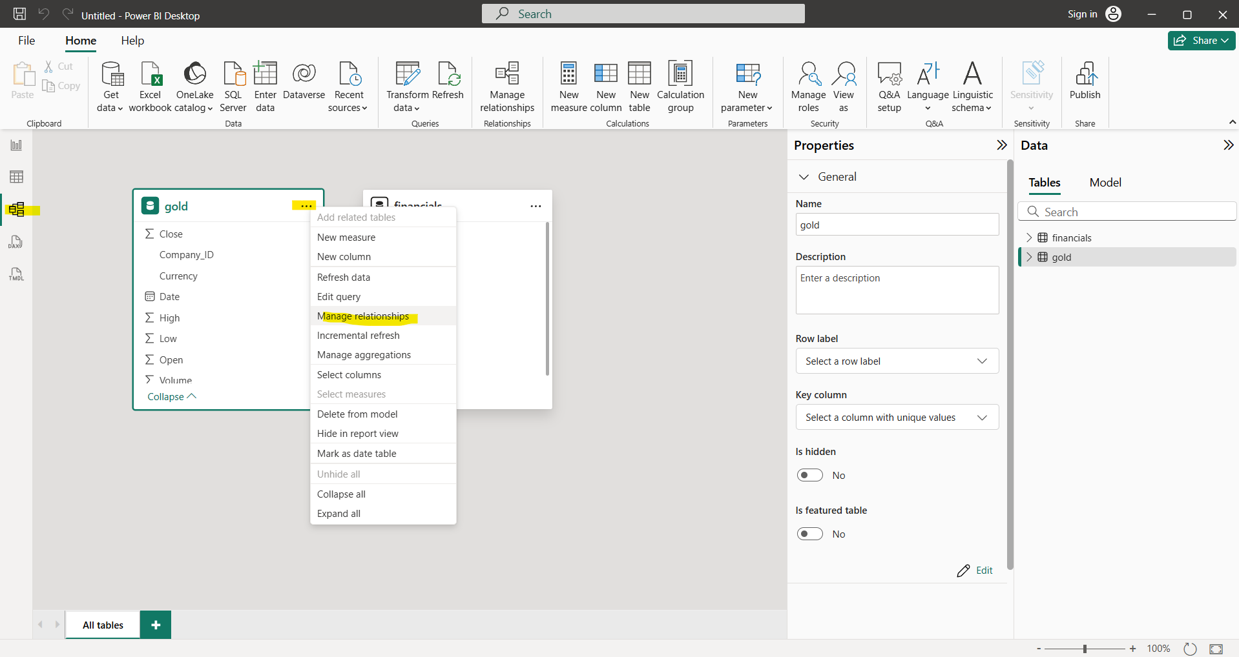

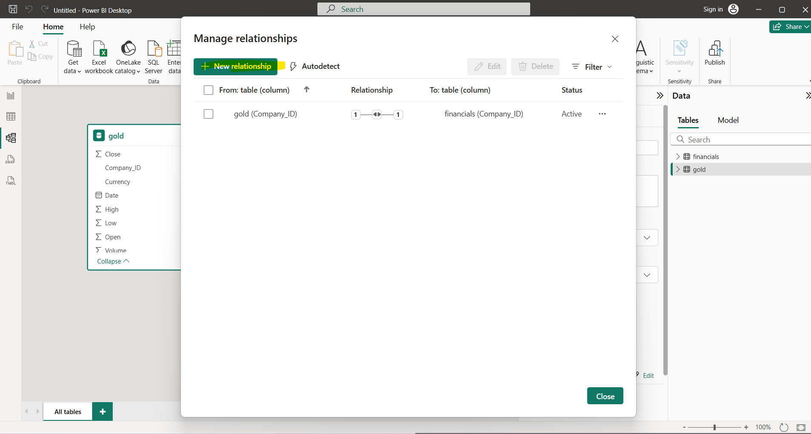

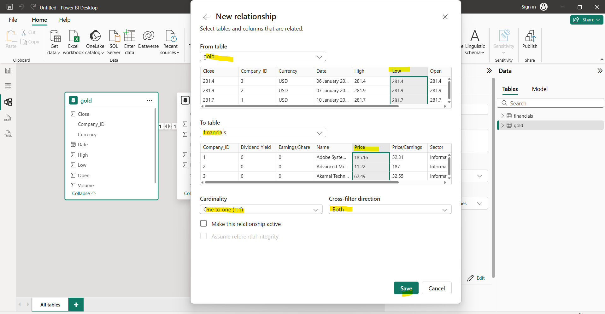

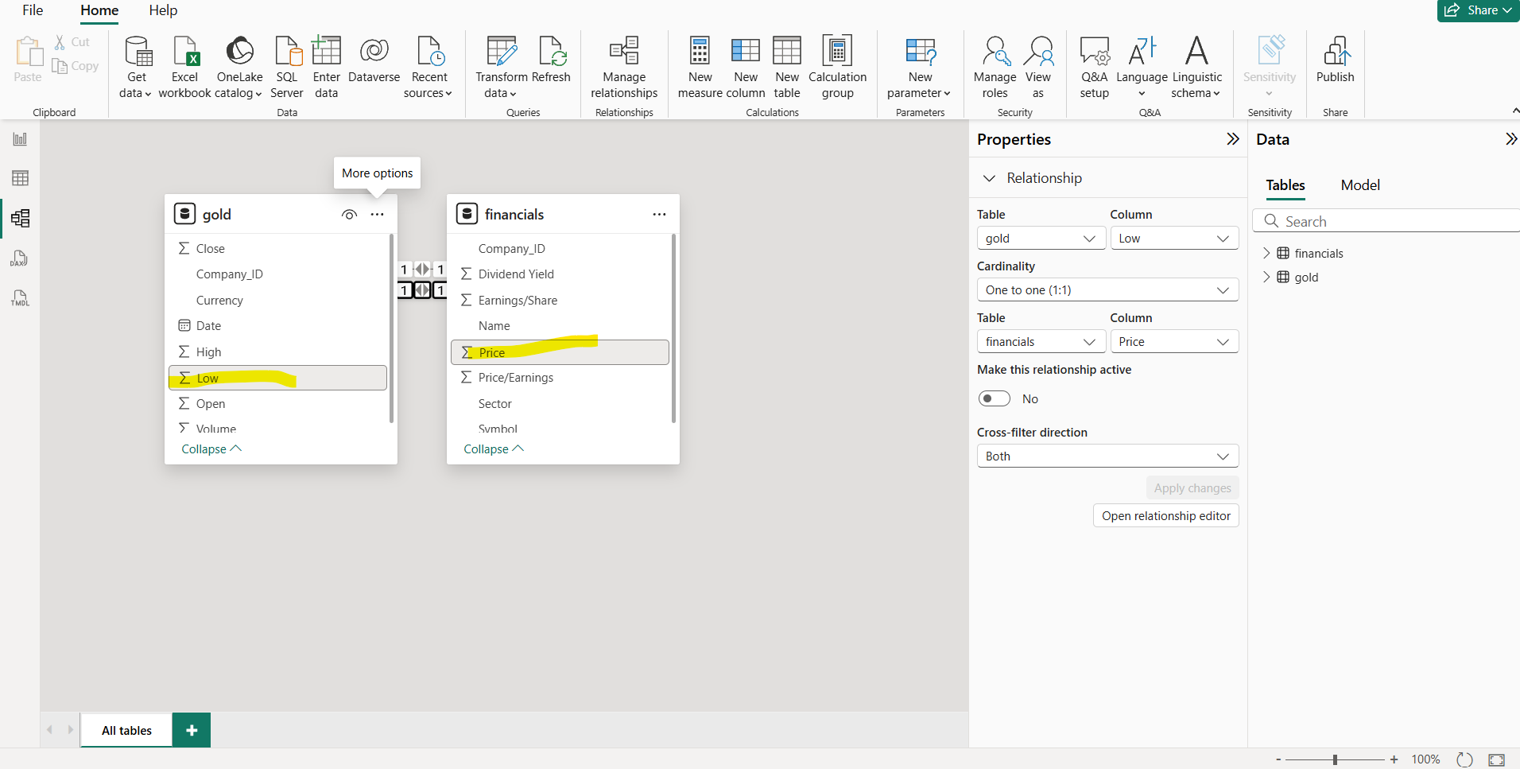

**Types of relationship**

**1. One-to-One (1:1)**

👉 Each record in one sheet relates to exactly **one** record in another.

**Example (financials ↔ gold):**

* Suppose each company in financials has exactly **one gold contract** in gold.
* Table financials → Company_ID = 101, Name = ABC Ltd, Revenue = 500M
* Table gold → Company_ID = 101, Gold_Contract_ID = G001, Quantity = 120kg

🔗 Relationship: **Each company → one gold contract only.**

**2. One-to-Many (1:N)**

👉 One record in the first sheet relates to **multiple** records in the second.

**Example:**

* A single company in financials may trade in gold **multiple times**.
* Table financials → Company_ID = 101, Name = ABC Ltd
* Table gold →
  + Company_ID = 101, Gold_Contract_ID = G001, Quantity = 120kg
  + Company_ID = 101, Gold_Contract_ID = G002, Quantity = 200kg

🔗 Relationship: **One company → many gold contracts.**

**3. Many-to-Many (M:N)**

👉 Multiple records in one sheet relate to **multiple** records in the other.

**Example:**

* Companies can share multiple gold contracts, and contracts can belong to multiple companies.
* Table financials:
  + Company_ID = 101, Name = ABC Ltd
  + Company_ID = 102, Name = XYZ Ltd
* Table gold:
  + Gold_Contract_ID = G001, Quantity = 120kg
  + Gold_Contract_ID = G002, Quantity = 300kg
* A **link table** (company_gold) is needed:
  + Company_ID=101, Gold_Contract_ID=G001
  + Company_ID=101, Gold_Contract_ID=G002
  + Company_ID=102, Gold_Contract_ID=G001

🔗 Relationship: **Companies ↔ multiple gold contracts, contracts ↔ multiple companies.**

**CREATING NEW AND QUICK MEASURE**

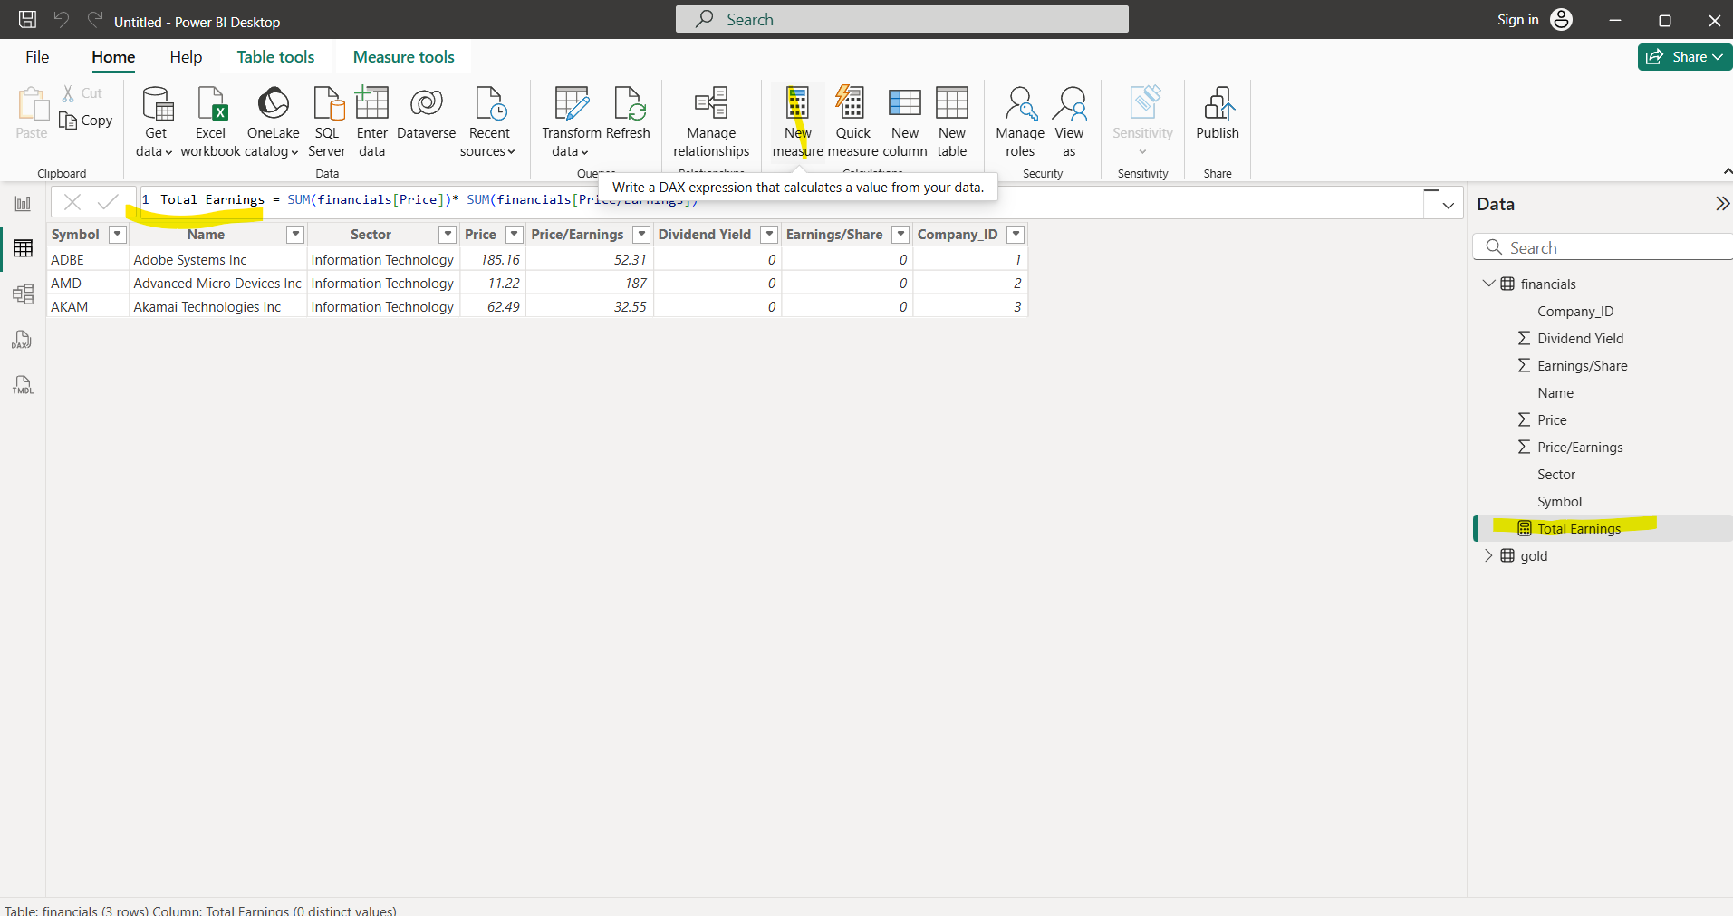

In above we cant multiple two column values without sum function Because **measures work on aggregated data**, not row-level context.

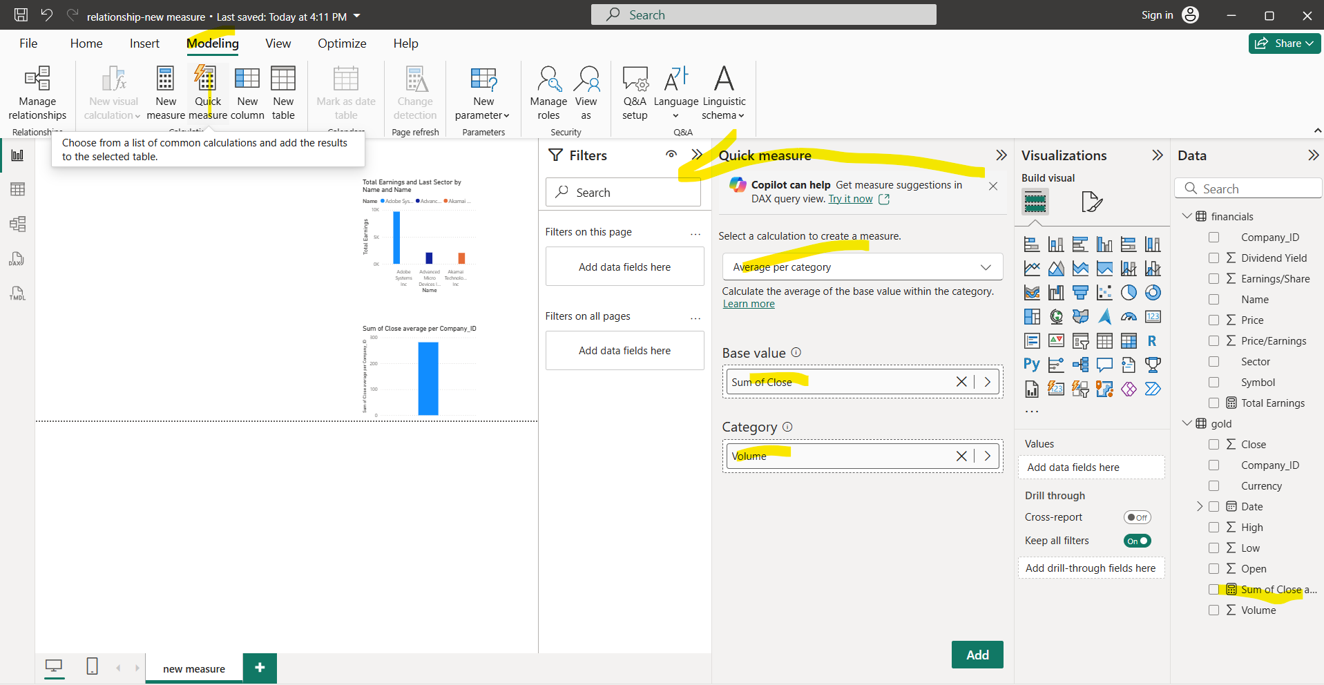

• **New Measure**: You manually write a DAX formula to define a calculation. a **new measure** is created in the model and not automatically added as a column in a table; it can be used in visuals.

• **Quick Measure**: Power BI auto-generates the DAX for you based on a template (like running totals, averages, etc.).

**Quick Measure** will choose from a list of common calculations and add the results to the selected table.

**PARAMETRE**

A **parameter** in Power BI allows dynamic filtering or what-if analysis by letting users change values that affect calculations and visuals.